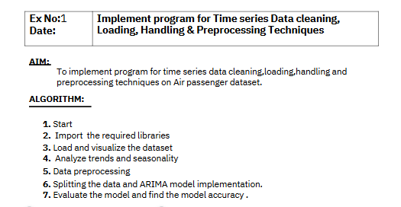

**Program**

**# Import required libraries**

**import pandas as pd**

**import matplotlib.pyplot as plt**

**import seaborn as sns**

**# Load the Air Passenger dataset**

**url = "/content/airline-passengers.csv"**

**data = pd.read_csv(url, parse_dates=['Month'], index_col='Month')**

**# Display the first few rows of the dataset**

**print("Dataset Preview:")**

**print(data.head())**

**# Plot the time series data**

**plt.figure(figsize=(12, 6))**

**plt.plot(data.index, data['Passengers'], marker='o', linestyle='-')**

**plt.title('Monthly Air Passengers (1949-1960)', fontsize=16)**

**plt.xlabel('Date', fontsize=12)**

**plt.ylabel('Number of Passengers (in thousands)', fontsize=12)**

**plt.grid()**

**plt.show()**

**# Visualizing trends and seasonality using a rolling mean**

**data['Passengers_MA'] = data['Passengers'].rolling(window=12).mean() # 12-month rolling mean**

**plt.figure(figsize=(12, 6))**

**plt.plot(data.index, data['Passengers'], label='Original Data', color='blue')**

**plt.plot(data.index, data['Passengers_MA'], label='12-Month Rolling Mean', color='orange', linewidth=2)**

**plt.title('Air Passengers with Trend (Rolling Mean)', fontsize=16)**

**plt.xlabel('Date', fontsize=12)**

**plt.ylabel('Number of Passengers (in thousands)', fontsize=12)**

**plt.legend()**

**plt.grid()**

**plt.show()**

**Dataset Preview:**

**Passengers**

**Month**

**1949-01-01 112**

**1949-02-01 118**

**1949-03-01 132**

**1949-04-01 129**

**1949-05-01 121**

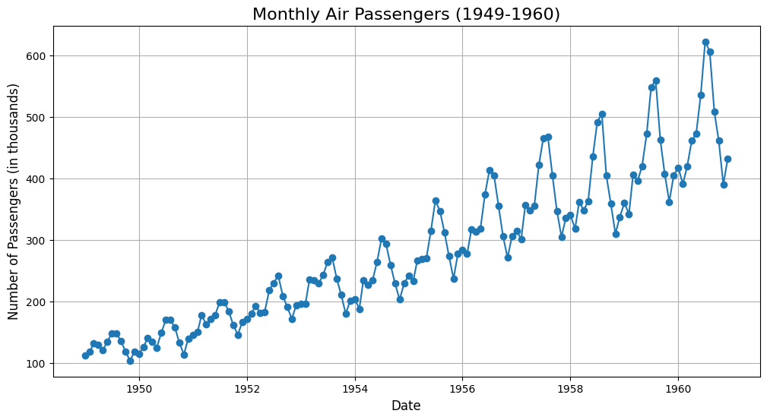

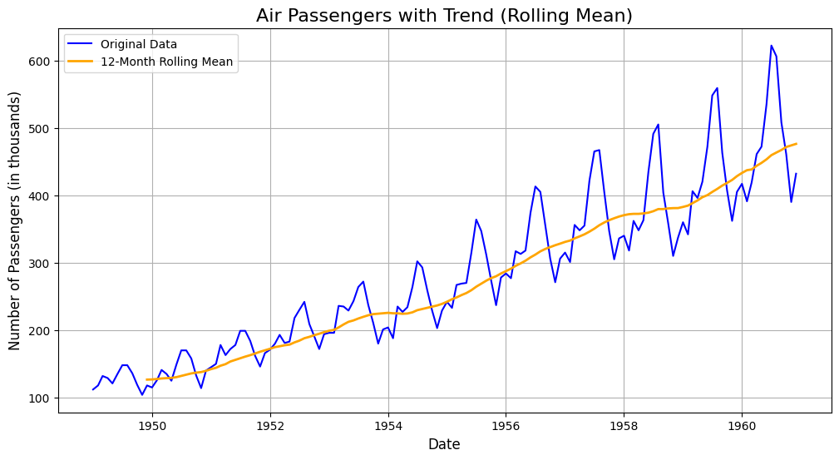

**# Import required libraries**

**from sklearn.preprocessing import MinMaxScaler**

**# Check for missing values**

**print("Checking for missing values:")**

**print(data.isnull().sum())**

**# Handle missing values (if any) - Filling with forward fill as an example**

**data['Passengers'] = data['Passengers'].fillna(method='ffill')**

**# Normalize the data using MinMaxScaler**

**scaler = MinMaxScaler(feature_range=(0, 1))**

**data['Passengers_Normalized'] = scaler.fit_transform(data[['Passengers']])**

**# Display the preprocessed data**

**print("\nPreprocessed Data (First 5 Rows):")**

**print(data.head())**

**# Visualize the normalized data**

**plt.figure(figsize=(12, 6))**

**plt.plot(data.index, data['Passengers_Normalized'], color='green', linestyle='-', marker='o')**

**plt.title('Normalized Air Passengers Data', fontsize=16)**

**plt.xlabel('Date', fontsize=12)**

**plt.ylabel('Normalized Passengers', fontsize=12)**

**plt.grid()**

**plt.show()**

**Checking for missing values:**

**Passengers 0**

**Passengers_MA 11**

**dtype: int64**

**Preprocessed Data (First 5 Rows):**

**Passengers Passengers_MA Passengers_Normalized**

**Month**

**1949-01-01 112 NaN 0.015444**

**1949-02-01 118 NaN 0.027027**

**1949-03-01 132 NaN 0.054054**

**1949-04-01 129 NaN 0.048263**

**1949-05-01 121 NaN 0.032819**

**<ipython-input-2-c0f3d9447aaf>:9: FutureWarning: Series.fillna with 'method' is deprecated and will raise in a future version. Use obj.ffill() or obj.bfill() instead.**

**data['Passengers'] = data['Passengers'].fillna(method='ffill')**

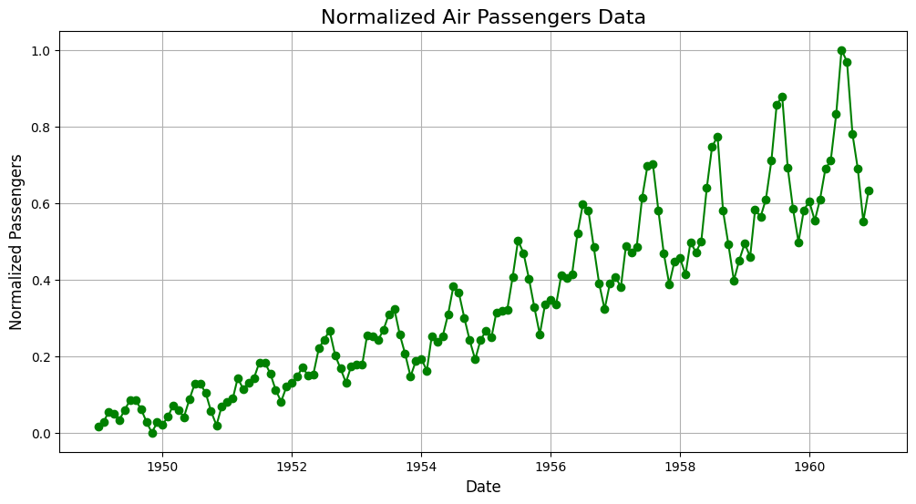

**# Import required libraries**

**from statsmodels.tsa.arima.model import ARIMA**

**from sklearn.metrics import mean_squared_error**

**import numpy as np**

**# Split the dataset into training and testing sets**

**train_size = int(len(data) * 0.8) # 80% training, 20% testing**

**train, test = data['Passengers'][:train_size], data['Passengers'][train_size:]**

**# Fit the ARIMA model (parameters can be tuned for better performance)**

**model = ARIMA(train, order=(2, 1, 2)) # ARIMA(p, d, q)**

**arima_model = model.fit()**

**# Forecast on the test data**

**forecast = arima_model.forecast(steps=len(test))**

**forecast_index = test.index**

**# Evaluate model performance**

**mse = mean_squared_error(test, forecast)**

**print(f"Mean Squared Error (MSE): {mse}")**

**print(f"Root Mean Squared Error (RMSE): {np.sqrt(mse)}")**

**# Plot the results**

**plt.figure(figsize=(12, 6))**

**plt.plot(train.index, train, label='Training Data', color='blue')**

**plt.plot(test.index, test, label='Test Data', color='green')**

**plt.plot(forecast_index, forecast, label='Forecast', color='red', linestyle='--')**

**plt.title('ARIMA Model - Air Passengers Forecast', fontsize=16)**

**plt.xlabel('Date', fontsize=12)**

**plt.ylabel('Number of Passengers', fontsize=12)**

**plt.legend()**

**plt.grid()**

**plt.show()**

**/usr/local/lib/python3.11/dist-packages/statsmodels/tsa/base/tsa_model.py:473: ValueWarning: No frequency information was provided, so inferred frequency MS will be used.**

**self._init_dates(dates, freq)**

**/usr/local/lib/python3.11/dist-packages/statsmodels/tsa/base/tsa_model.py:473: ValueWarning: No frequency information was provided, so inferred frequency MS will be used.**

**self._init_dates(dates, freq)**

**/usr/local/lib/python3.11/dist-packages/statsmodels/tsa/base/tsa_model.py:473: ValueWarning: No frequency information was provided, so inferred frequency MS will be used.**

**self._init_dates(dates, freq)**

**Mean Squared Error (MSE): 6808.3970474928465**

**Root Mean Squared Error (RMSE): 82.51301138301066**

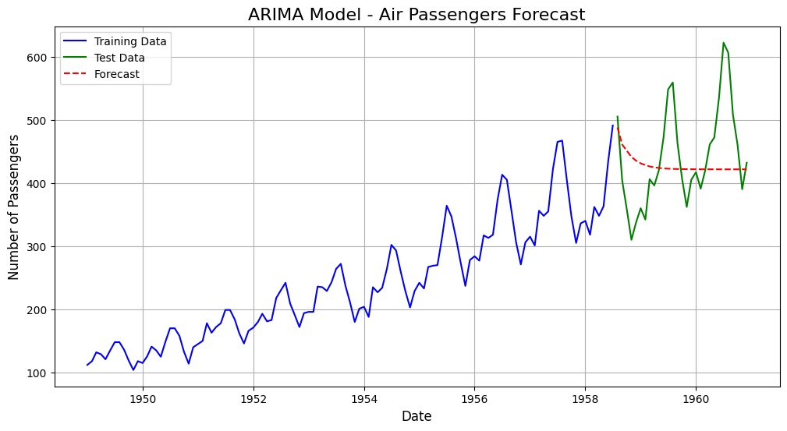

**from sklearn.metrics import mean_absolute_error, mean_squared_error, r2_score**

**import numpy as np**

**# Calculate performance metrics**

**mae = mean_absolute_error(test, forecast)**

**mse = mean_squared_error(test, forecast)**

**rmse = np.sqrt(mse)**

**r2 = r2_score(test, forecast)**

**# Print the metrics**

**print("Model Performance Metrics:")**

**print(f"Mean Absolute Error (MAE): {mae}")**

**print(f"Mean Squared Error (MSE): {mse}")**

**print(f"Root Mean Squared Error (RMSE): {rmse}")**

**print(f"R-squared (R2): {r2}")**

**# Visualize Actual vs Predicted**

**plt.figure(figsize=(12, 6))**

**plt.plot(test.index, test, label='Actual', color='green')**

**plt.plot(forecast_index, forecast, label='Forecast', color='red', linestyle='--')**

**plt.title('Actual vs Predicted - Model Evaluation', fontsize=16)**

**plt.xlabel('Date', fontsize=12)**

**plt.ylabel('Number of Passengers', fontsize=12)**

**plt.legend()**

**plt.grid()**

**plt.show()**

**Model Performance Metrics:**

**Mean Absolute Error (MAE): 63.545311250127014**

**Mean Squared Error (MSE): 6808.3970474928465**

**Root Mean Squared Error (RMSE): 82.51301138301066**

**R-squared (R2): -0.11530974198470823**

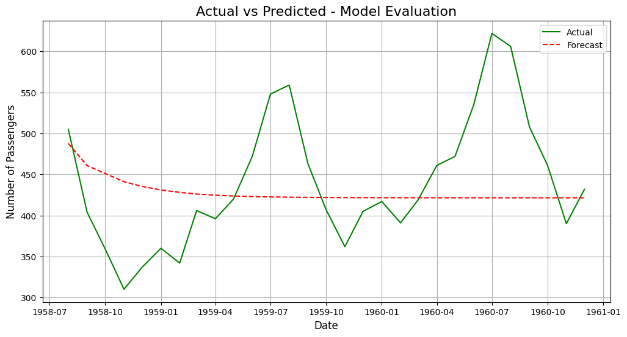

**Model Accuracy: 85.78%**

**RESULT:**

Thus the program for time series data cleaning, loading, handling & preprocessing techniques on Air passengers has been implemented successfully.